DIS-Min-**Sauratown Mountains**

itacolumite, a flexible sandstone found only here and in Brazil

The **Sauratown Mountains**, which are sometimes called "the mountains away from the mountains", are an isolated [mountain range](https://en.wikipedia.org/wiki/Mountain_range) located within [Stokes](https://en.wikipedia.org/wiki/Stokes_County,_NC) and [Surry](https://en.wikipedia.org/wiki/Surry_County,_NC) counties in the [U.S. state](https://en.wikipedia.org/wiki/U.S._state) of [North Carolina](https://en.wikipedia.org/wiki/North_Carolina).[[1]](https://en.wikipedia.org/wiki/Sauratown_Mountains" \l "cite_note-StateParksBook-HangingRock-1) The vast majority of the range is located in Stokes County, and even though the range occupies only 5% of Stokes County's area, it dominates the county's scenery from almost every direction. The Sauras rise sharply 800 to 1,700 feet (244 to 518 meters) above the surrounding terrain. The Sauratown Mountains were named after the "[Sauras](https://en.wikipedia.org/wiki/Saura)", a Native American tribe that lived in the area before European settlers arrived in the early 1700s.[[1]](https://en.wikipedia.org/wiki/Sauratown_Mountains" \l "cite_note-StateParksBook-HangingRock-1) The range consists of rugged, heavily [forested](https://en.wikipedia.org/wiki/Forest) ridges frequently broken by large [quartzite](https://en.wikipedia.org/wiki/Quartzite) rock cliffs that can be seen for miles. The Sauratown Mountains are known for offering some of the best rock climbing in North Carolina. The highest point in the Sauratown Mountains is [Moore's Knob](https://en.wikipedia.org/wiki/Moore's_Knob), which rises to 2,579 feet (786 m).

The range is home to [Hanging Rock State Park](https://en.wikipedia.org/wiki/Hanging_Rock_State_Park), which was formed in 1936 and contains Moore's Knob and other prominent peaks in the Sauratown Mountains.

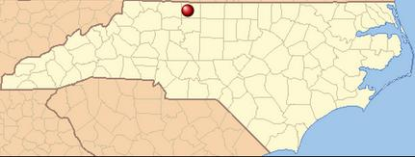

Location of Hanging Rock State Park in North Carolina

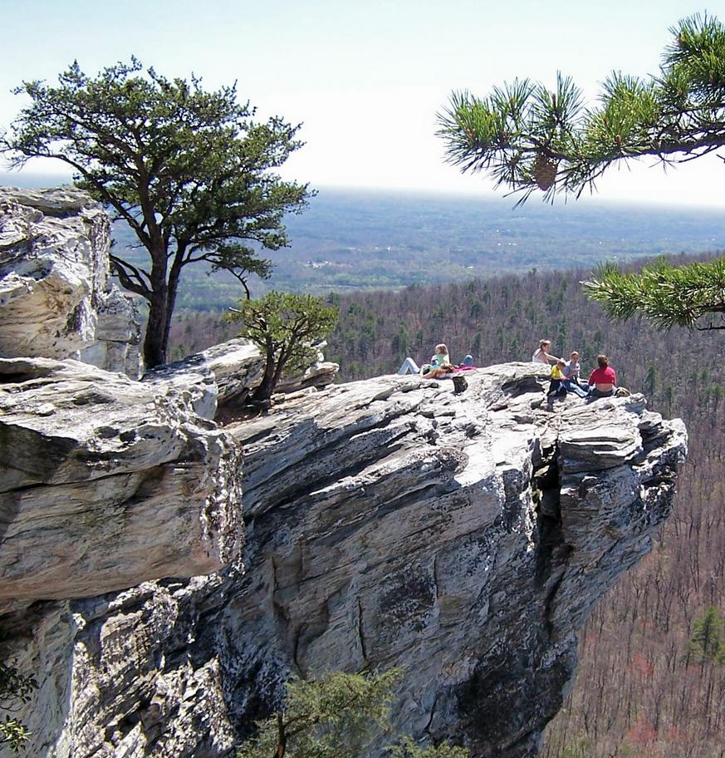

Hanging Rock, North Carolina. Trees are [*Pinus pungens*](https://commons.wikimedia.org/wiki/Pinus_pungens).

Uniquely shaped [Pilot Mountain](https://en.wikipedia.org/wiki/Pilot_Mountain_(North_Carolina)) is also located in the range.[[2]](https://en.wikipedia.org/wiki/Sauratown_Mountains" \l "cite_note-StateParksBook-PilotMtn-2)[[3]](https://en.wikipedia.org/wiki/Sauratown_Mountains" \l "cite_note-NicheGuide-PilotMtn-3) [Pilot Mountain State Park](https://en.wikipedia.org/wiki/Pilot_Mountain_State_Park) encompasses the westernmost end of the range.

**Pilot Mountain**, a metamorphic [quartzite](https://en.wikipedia.org/wiki/Quartzite) [monadnock](https://en.wikipedia.org/wiki/Monadnock) rising to a peak 2,421 feet (738 m) above [sea level](https://en.wikipedia.org/wiki/Sea_level), is one of the most distinctive natural features in the [U.S. state](https://en.wikipedia.org/wiki/U.S._state) of [North Carolina](https://en.wikipedia.org/wiki/North_Carolina). It is a remnant of the ancient chain of [Sauratown Mountains](https://en.wikipedia.org/wiki/Sauratown_Mountains). The [Saura](https://en.wikipedia.org/wiki/Saura) Indians, the region's earliest known inhabitants, called the mountain "Jomeokee", meaning "great guide" Pilot Mountain, like the rocky escarpments in nearby Hanging Rock State Park, is a remnant of the ancient Sauratown Mountain range.

References

Biggs, Jr., Walter C.; Parnell, James F. (1993) [1989]. "Piedmont". State Parks of North Carolina (2nd ed.). Winston-Salem, North Carolina: John F. Blair. pp. 176–187.